**IoT Project**

|  |  |  |  |  |  |
| --- | --- | --- | --- | --- | --- |
|  |  |  |  |  |  |
| **Instructions** |  |  |  |  |  |
| Every screenshot requested in this workbook is compulsory and carries 8 marks. | | | | | |
| Your AWS account ID must be clearly visible in every screenshot using the AWS console; missing id or using someone else's id is not permitted. Such cases will be considered as plagiarism and severe penalty will be imposed. | | | | | |
| All screenshots must be in the order mentioned under "Expected Screenshots" for every step | | | | | |
| DO NOT WAIT UNTIL THE LAST MINUTE. The program office will not extend the project submission deadline under any circumstances. | | | | | |
| The file should be renamed in the format BATCH_FIRSTNAME_LASTNAME_PROJECT1.  For example: ACSE_Batch_VIJAY_DWIVEDI_PROJECT1.docx | | | | | |
|  |  |  |  |  |  |
|  |  |  |  |  |  |
| **Resource Clean Up** | |  |  |  |  |
| Cloud is always a pay per use model and all resources/services that we consume are chargeable. Cleaning up when you’ve completed your lab or project is always necessary. This is true whether you’re doing a lab or implementing a project at your workplace. | | | | | |
| After completing the lab, make sure to delete each resource created in reverse chronological order. | | | | | |

## Creating Things, DynamoDB table

| Step number | a |  |  |
| --- | --- | --- | --- |
| Step name | IoT Core and Things |  |  |
| Instructions | 1) Goto IoT core and create the types of things you wish to create.  2) Create at least one group and parent group that will be attached to things.  3) Create a policy that will be attached with newly created IoT devices.  4) Create at least two devices on the IoT core to send and receive data. |  |  |
| Expected screenshots | 1. Screenshot of successfully create thing type 2. Screenshot of successfully created group. 3. Screenshot of successfully created policy page. 4. Screenshot of successfully created thing. |  |  |

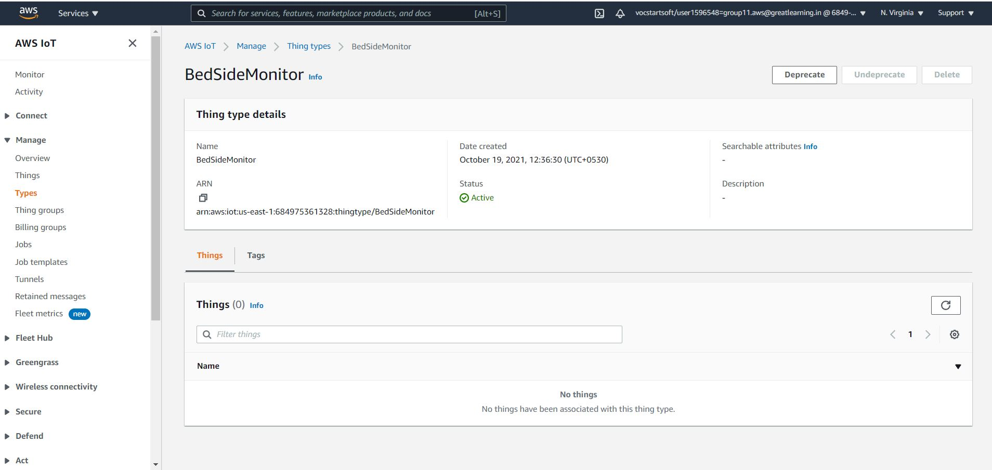

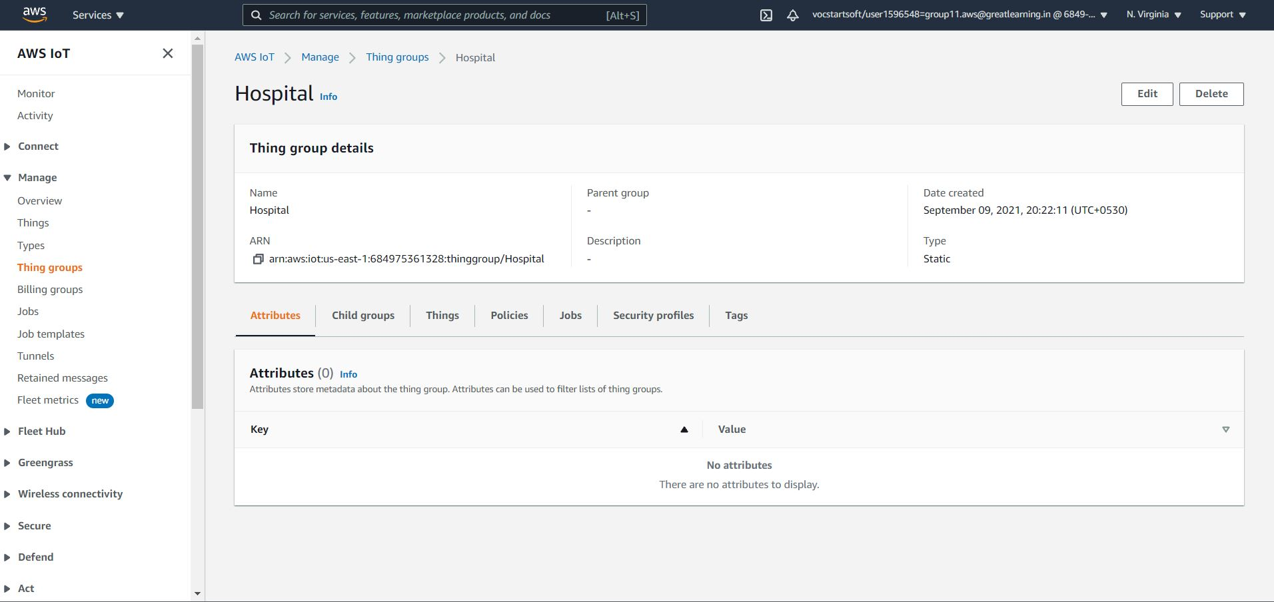

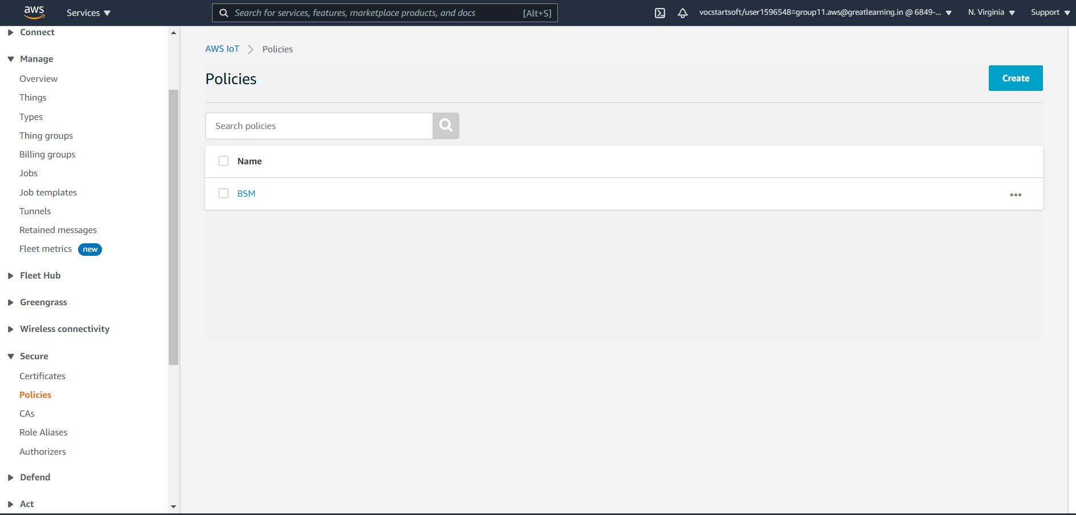

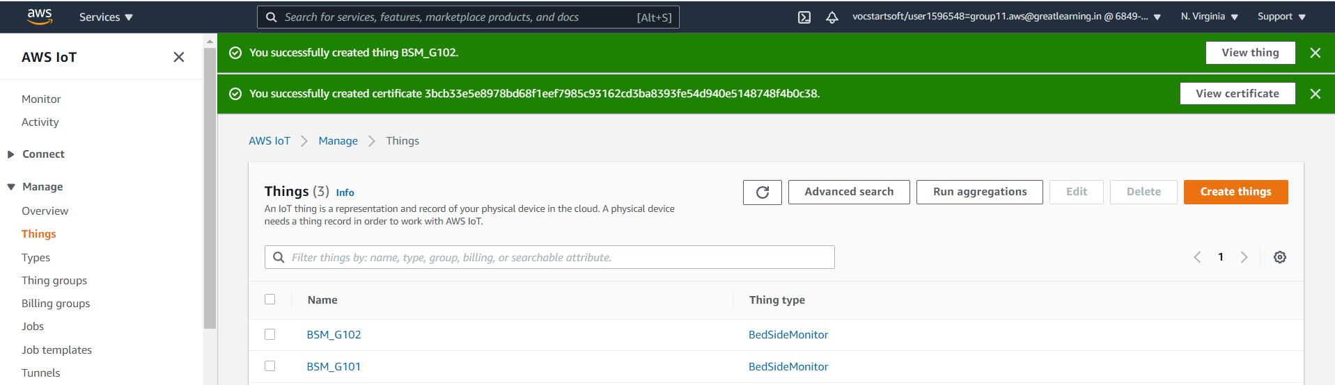

| Step number | b |  |  |
| --- | --- | --- | --- |
| Step name | DynamoDB |  |  |
| Instructions | 1) Goto DynamoDB console or use python script to create the table to store the raw_data, aggregate_data and anomaly-data with appropriate partition key and sort key  2) Assign the name to the table to store the raw data  3) The name of the tables should be clearly visible in the screenshot. |  |  |
| Expected screenshots | 1. Screenshot of successfully created table to hold the raw data. (Empty table) 2. Screenshot of successfully created table to hold the aggregated/ data. (Empty table) 3. Screenshot of successfully created table to hold the anomaly data. (Empty table) |  |  |

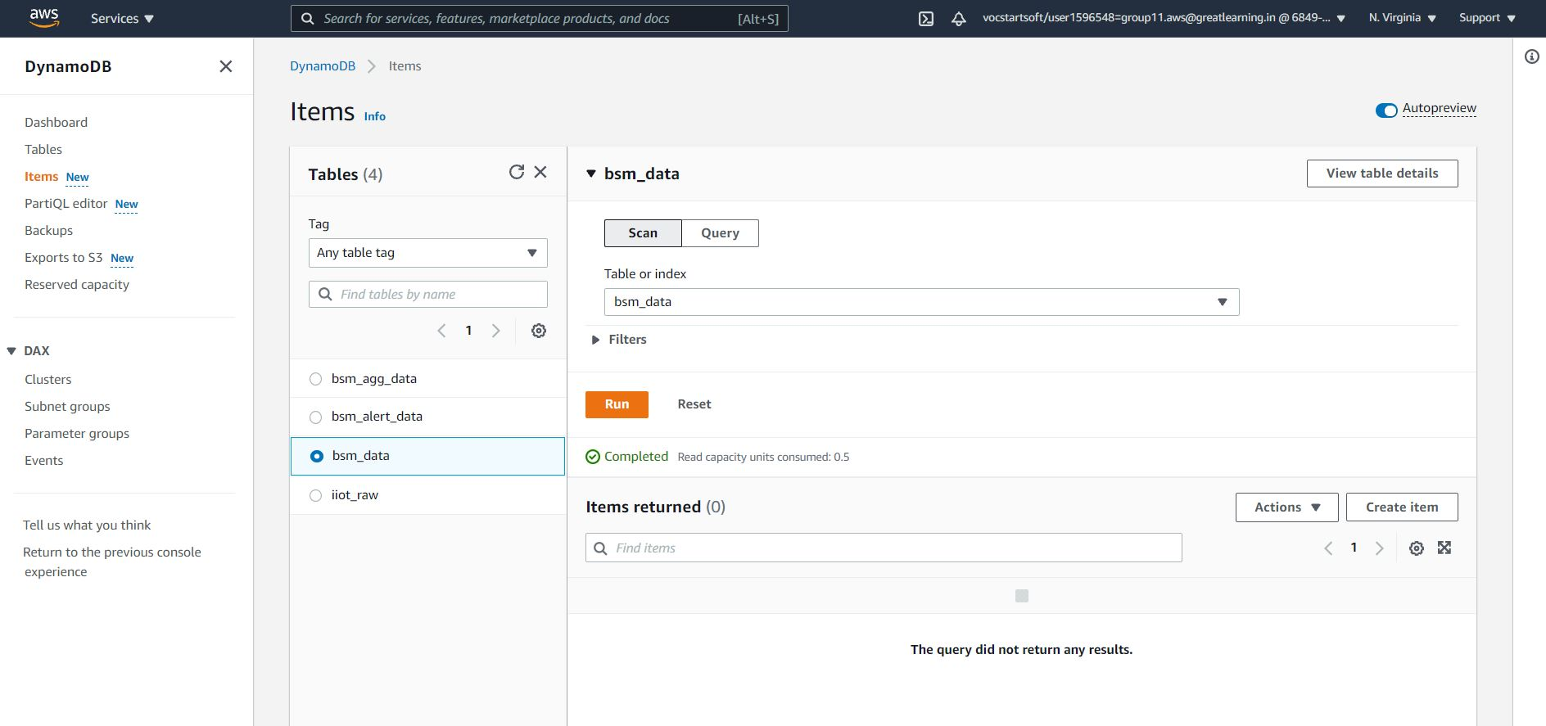

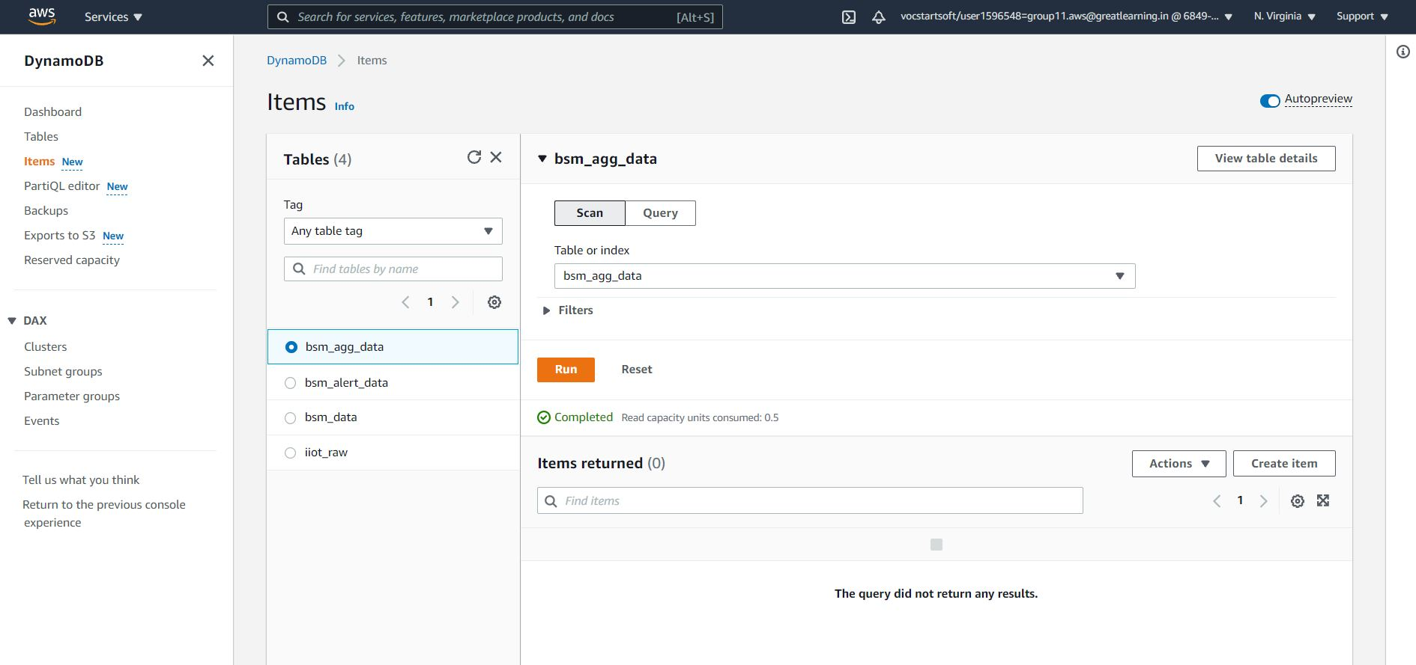

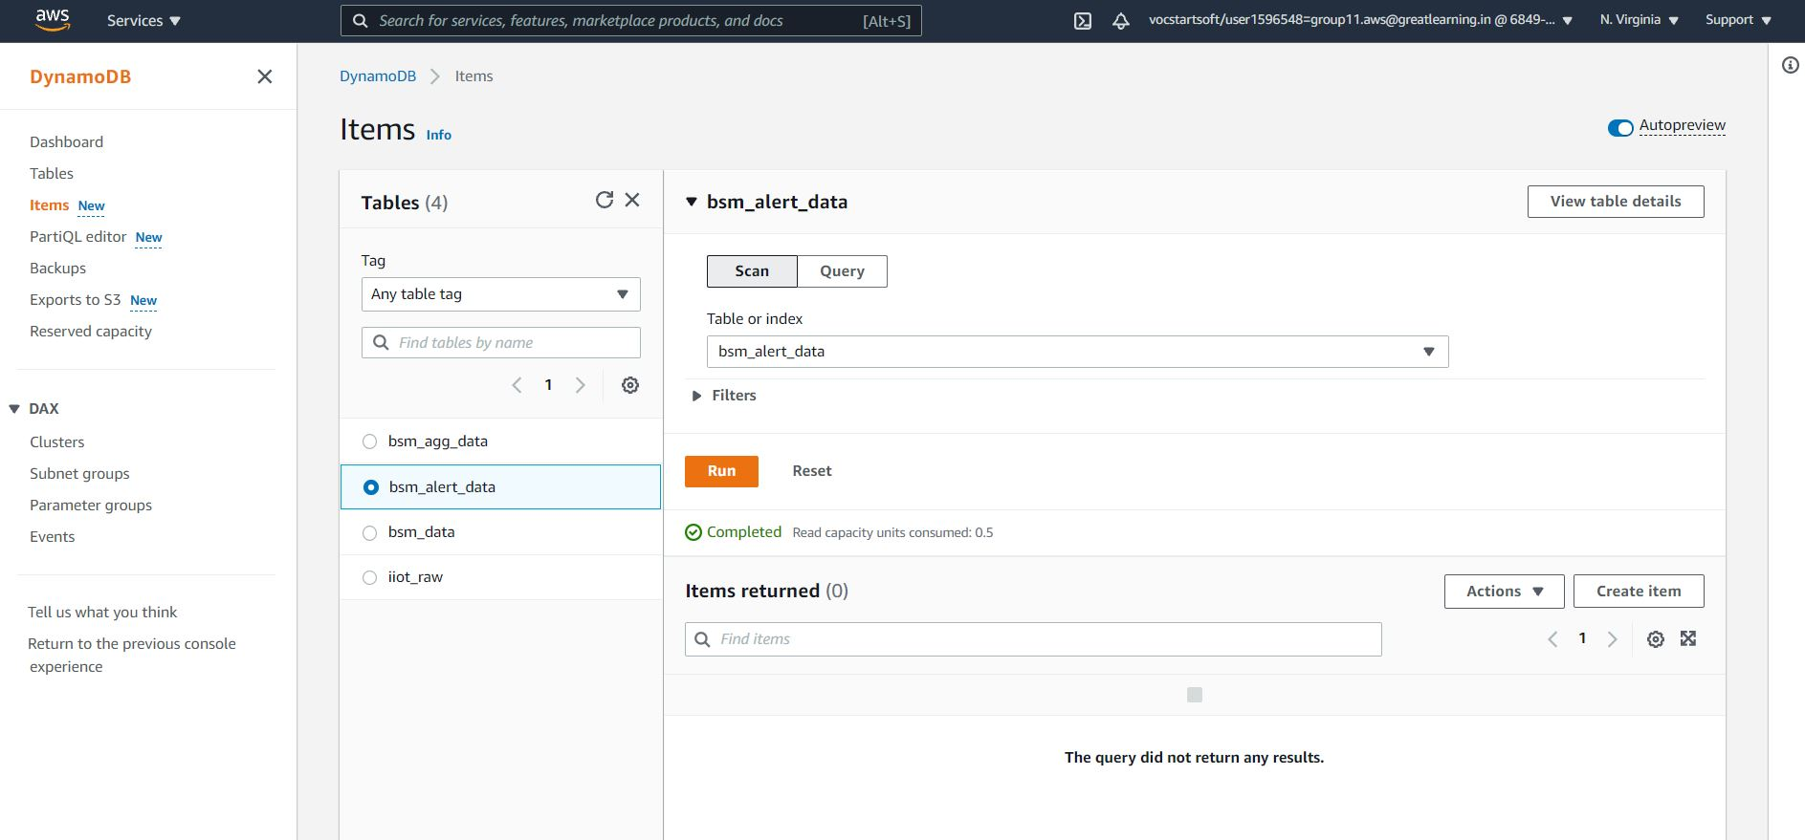

| Step number | c |  |  |
| --- | --- | --- | --- |
| Step name | Rule creation to push raw data |  |  |
| Instructions | 1) Goto IoT core and create rule to push simulated data in the raw data table created in the above step  2) Once the rule is created, run the python script to push data on AWS MQTT. If the created rule is valid then data will be available in the previously created table. |  |  |
| Expected screenshots | 1. Screenshot of successfully created rule to push the raw data 2. Screenshot of data available in the AWS MQTT |  |  |

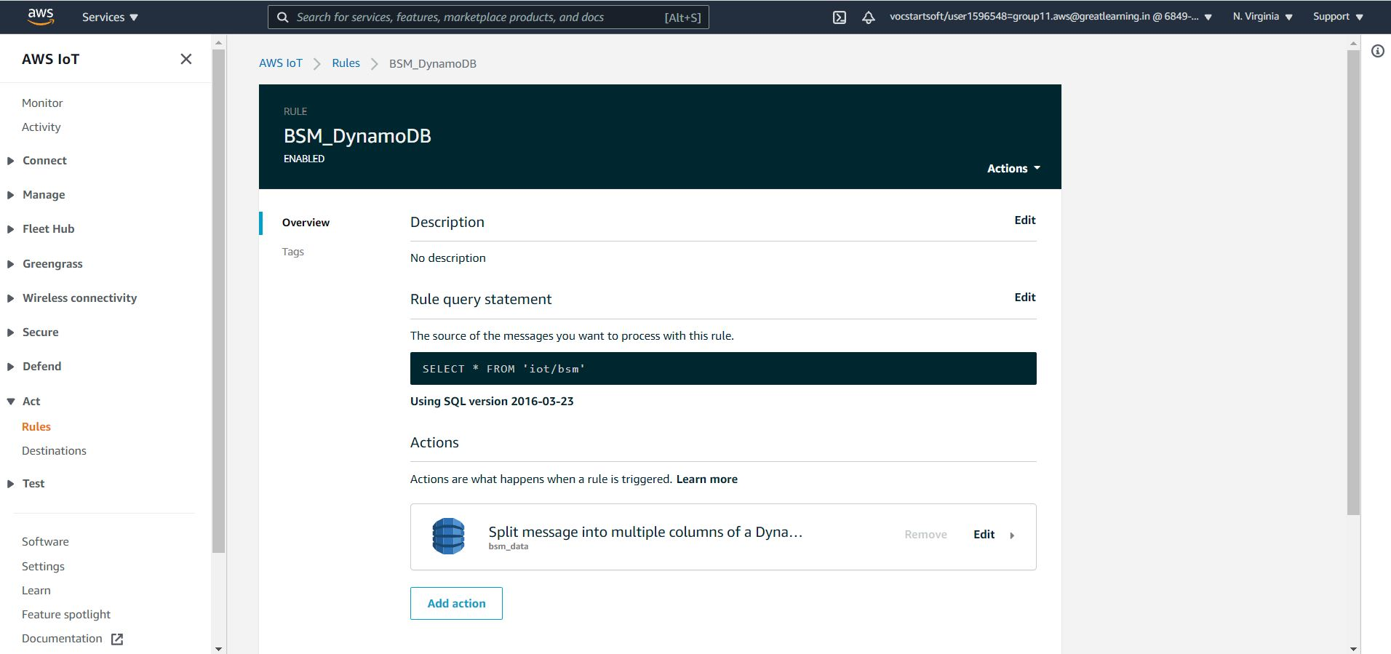

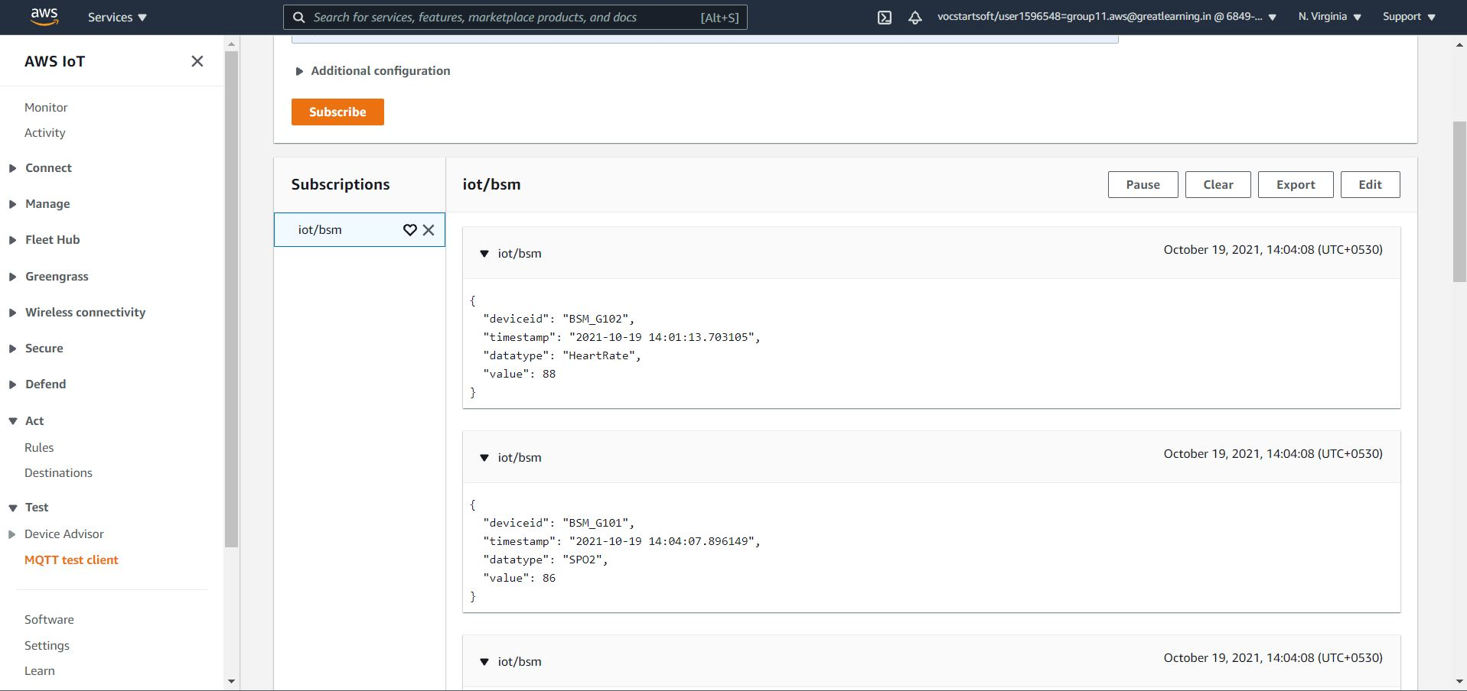

| Step number | d |  |  |
| --- | --- | --- | --- |
| Step name | Data in the DynamoDB table |  |  |
| Instructions | 1) Once the tables are created and raw data rule is created to push the data  2) Perform aggregation as mentioned in Task-2 of the problem statement, once done the data should be there in the newly created table.  3) Perform anomaly as per the task-3 available in the problem statement and then push the data in the newly created table. |  |  |
| Expected screenshots | 1. Screenshot of populated raw data in the table 2. Screenshot of populated aggregated data in the table 3. Screenshot of populated anomaly data in the table |  |  |

